Chewuch River Right Fish Enhancement Project Description
COUNTY: Okanogan, WA LOCATION: Parcel # 9800750002
Location: 12 miles North of Winthrop Camp Ground: Eight Mile Creek
Closure: June 1, 2015 to October 1, 2015

The Yakama Nation, (YN), and Washington Department of Fish and Wildlife, (WDFW), have partnered together to restore a remnant side channel at the Eightmile Creek Camp Ground. The Chewuch River Right project will improve habitat for ESA listed species, Upper Columbia Spring Chinook, Upper Columbia Steelhead, and Bull trout by restoring and connecting off channel habitat, adding stream complexity, creating a functioning wetland, and the development of some new campground sites.

The YN and WDFW will be reactivating sections of a historical side channel along the right side of the valley floodplain at the Eightmile Creek Camp Ground. The Camp Ground will be closed from June 15th to October 1, 2015. A sign will be directing traffic and campers to the Falls Creek Camp Ground, 1.5 miles north, during that time.

The side channel habitat functions resulting from the project would benefit salmonids as well as other aquatic, amphibian, and terrestrial flora and fauna, by increasing heterogeneity (diverse habitats functioning together), of the terrain and hydrology of the floodplain landscape. Restoring flow to this area will create 2,500 feet of stream winding through forested floodplain, before exiting to an oxbow and rejoining the Chewuch River. Aquatic habitat features such as pools, runs, riffles, and wood structures will be constructed throughout the channel length.

Map of Project

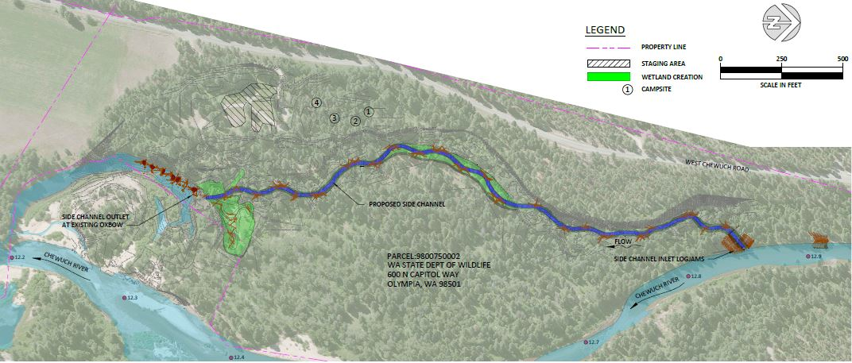

The project includes a total of five engineer log structures (ELS), three of which are designed for the inlet of the side channel. Large wood in streams is important because it provides cover from predators and creates the hydraulics necessary for the creation of scour pools. Pools with cover are critical habitats for both adult and juvenile salmonids.

The Wetland creation will be achieved by removing 0.8 acre of historic wetland fill associated with the adjacent camp sites and vehicle access. Human access to the re-established wetland area will be prevented by removal of the existing roadway and by restoration of the historic side channel. Previously filled wetlands will be excavated down to native soils, and then planted with native herbaceous, shrub and plant species. Quality soils and vegetation will be salvaged in situ during the excavation phase and will be placed back on the surface of the enhanced side channel to facilitate site restoration.

Extensive plantings of native vegetation will occur once excavation activities are completed. An abundance of large pre-grown bare rooted cottonwood trees, aspens, and willows will be planted by hand. Additional riparian and wetland nursery grown potted shrub and tree species will be planted by hand throughout the project zone. Broadcast seeding of upland and riparian native grass mixes and wetland sod mixes will occur, as well as hand planting of nursery grown bunchgrass, sedge and rush plugs throughout the project area.

June 15, 2015 -Eight Mile Creek Camp Ground Closes
July 1, 2015 -Begin in water work schedule
August 1, 2015 -Begin construction of the side Channel and wetland development
September 15, 2105 -Begin Revegetated Plantings
October 1, 2015 -Camp Ground opens to the public

