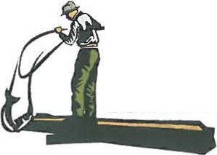
Yakama Nation Fisheries

Columbia River
Honor. Protect. Restore.

OFFICE
P 0 Box 151
401 Fort Road

PHONE

FAX
(509)865-6293

EMAIL

WEB
MEMORANDUM

Date: January 19, 2022

To: Tribal Fishers

From Fish and Wildlife Committee Gerald Lewis, Chairman
CC: Fisheries Harvest Coordinator
Roger Dick, Jr.

Subject: Fishers Meeting- January 31,2022
The Fish and Wildlife Committee directed Fisheries Staff to schedule a fishers meeting for Monday, January 31, 2022, from 10 a.m. to 4 p.m. via Zoom Meeting: Join ZoomGov Meeting: https://www.zoomgov.com/j/1614036887
Meeting ID: 161 403 6887
One tap mobile
+16692545252,,1614036887# US (San Jose)
+16692161590,,1614036887# US (San Jose)
Or email dicr@yakamafish-nsn.gov or begm@yakamafish-nsn.gov for email invite.
Topics for discussion include:

1. Winter Season 2022
a. Season Regulations
b. Sturgeon Guidelines and Catch
i. Bonneville Pool Guideline
ii. Winter Gillnet Season Structure
c. Smelt Information

2. Spring Season 2022
a. Forecasts and Catch Guidelines
b. Spring Season 2021 Review
c. Preliminary Fisheries Outlook

3. Other Topics
a. Expanded Icicle River Fishing Area 11:30am
b. Mid-Columbia Coho Program 11:45am
c. CRITFC Covid Update 1:00pm
d. In-Lieu/TFAS Sites, Salmon Marketing, Enforcement, Other?

