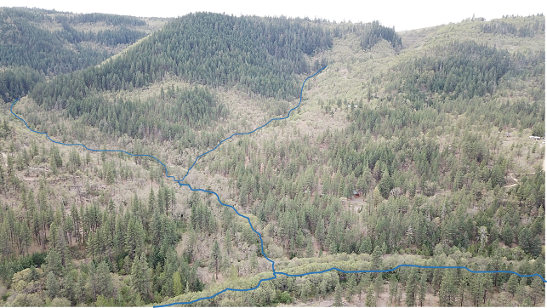

The Yakama Nation (YN), is soliciting a Request for Proposals for Engineering Design Services for two road crossings and habitat enhancement elements on a seasonal tributary of Swale Creek in south central Washington State. The crossings are located on two unnamed tributaries that flow into Swale Creek at river mile 0.5. Crossings will be designed to provide year round passage for aquatic species and longitudinal movement of flood flows, wood and sediment. The goal is to obtain designs at the 15% level by March 2021.

The project area encompasses 2 fish passage barriers at culverts located under Lover’s Lane Road. In addition to the passage barriers, habitat along Rattlesnake Gulch Creek was historically altered by placement of fill along the streambanks, cementing of alluvial rocks together, a small pour over dam to create a soaking pool and likely the removal of large wood from the channel and historic logging. Rattlesnake Gulch is a priority tributary due to its size, baseflow, good connection to Swale Creek, and its position low in the Swale Creek watershed.

The design process will entail topographic survey, evaluation of both culvert crossings, conceptual approaches to road crossings, conceptual ideas for floodplain/alluvial fan habitat enhancement elements, and identification of locations for channel structure additions (small diameter wood and posts). Final deliverable is 15-30% designs for crossings and habitat enhancement elements.

Response Deadline: September 23rd 2020, 5:00 pm

